Course information

Christopher Suitor

Ben Sylvester

Nana Nimako

Assignment: Final Project

THE CNB SWAPPER

Version <1.0>

Table Of Contents

Time Log 3

Introduction 5

Purpose 5

Definitions, acronyms, and abbreviations 5

Overall Description 5

Story Board 6

Data Dictionary 10

ER- Diagram 13

Schema 14

Specific requirements 15

|  |  |  |  |
| --- | --- | --- | --- |
| Time Log | | | |
| Estimated time to complete assignment => | | | 70 Hours |
| Date | Time Spent  (in hours) | Description | Author |
| 10/31 | 1 | Created git repo. Discussed project topic and group roles. | Christopher T. Suitor, Nana Nimako, Benjamin Sylvester |
| 11/03 | 0.5 | Creating time log and adding all members to it. Remind group of our email update due Monday. Work on email update | Benjamin Sylvester |
| 11/08 | 1.5 | Digressed our project idea to be more competitive for the CS Fair. Entered the CS Fair. Created a draft walkthrough of our website. Determined the functionalities we wanted. Created a draft of the database structure. | Christopher T. Suitor, Nana Nimako, Benjamin Sylvester |
| 11/12 | 1 | Created initial files and created the initial commit. Also created draft for look of home page. | Christopher Suitor |
| 11/13 | 1.5 | Added the final slider, nav and some css for the index page | Nana Nimako |
| 11/19 | 2 | Finished HTML for form. Working to create tables in PHP myAdmin to select and insert into.  Created the database, tables, and ERD diagram. Started working on saving form data to database | Benjamin Sylvester  Christopher Suitor |
| 11/29 | 3 | Continued work on the database. Populated tblHalls with all the UVM residential halls. Created the listbox of halls. Ammended the tables. Added form fields for comments, and I am working on image uploads. | Christopher Suitor |
| 11/29 | 2 | Created all the campus pages | Nana Nimako |
| 11/30 | 2 | finished uploading images process, finished htaccess creation/application/reorganization, finished the tables as of the current | Christopher Suitor |
| 11/30 | 1 | Group Meeting. Combined our code. Got an updated version on everybody's machine. CSS. | Christohper T. Suitor, Nana Nimako, Benjamin Sylvester |
| 12/02 | 2 | Edited the css for the pages and all the pictures that was taken fot the site | Nana Nimako |
| 12/03 | 1 | Created PHP for the listing/market page and sent it to the team | Christopher Suitor |
| 12/03 | 1.5 | Adding some new content and made a new page for the project | Nana Nimako |
| 12/04 | 6 | A lot of CSS, and got pages and tables working for in-class presentation. | Christopher T. Suitor, Nana Nimako |
| 12/06 | 2 | Fixed all HTML errors and css | Nana Nimako |
|  |  |  |  |
|  |  |  |  |
|  |  |  |  |
|  |  |  |  |
|  |  |  |  |
|  |  |  |  |
|  | 28 | <=Total Time Spent |  |
|  |  |  |  |

# Introduction

### Purpose

The purpose of this document is to describe the requirement specification for the web site “The CNB SWAPPER”.

The intended audience for this document is UVM undergraduate Students

*First it is the contract between you and the client. Second it is for the developer of the site. Two primary goals are:*

1. *Client gets a very good understanding of what you will be delivering.*
2. *Developer has a very good understanding of what they are going to create.*

### Definitions, acronyms, and abbreviations

*Sample for the client:*

ER Diagram – a diagram to represent the data you want to save with your system

W3 Validation – refers to both Html and CSS validation tool provided by the W3c.org. the html validator is located at:

<http://validator.w3.org/>

with the CSS validator located at:

<http://jigsaw.w3.org/css-validator/>

# Overall Description

The CNB Swapper is web application designed for UVM underclassmen to swap dorms with another student on campus. The student fills out our form application, and their application is sent to our explore page. From here, users can view all swap postings. If they see a dorm they would be interested in swapping into, they can select that dorm and request a swap. For a match to be made, the two users have to request each other's posting. When that occurs, an email message is sent to both users notifying them that a match has been made.

# Story Board

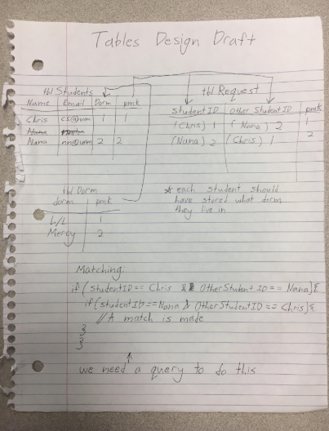

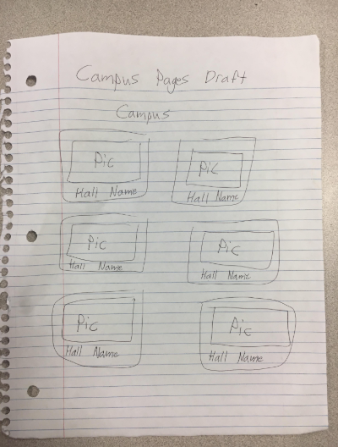

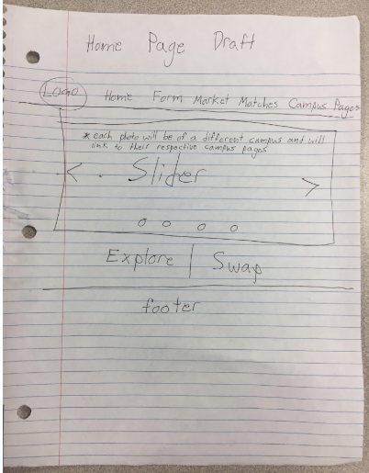

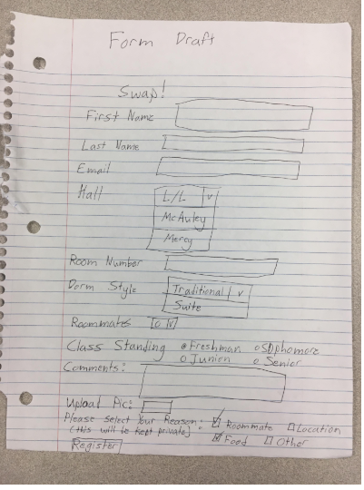

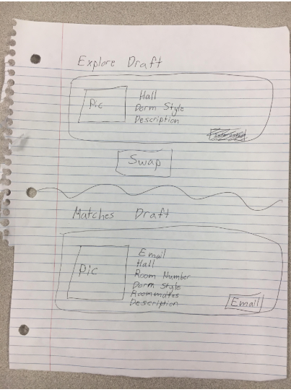

# Data Dictionary

Paste your Data Dictionary here. The final version is easy to get by exporting to the screen in phpMyadmin

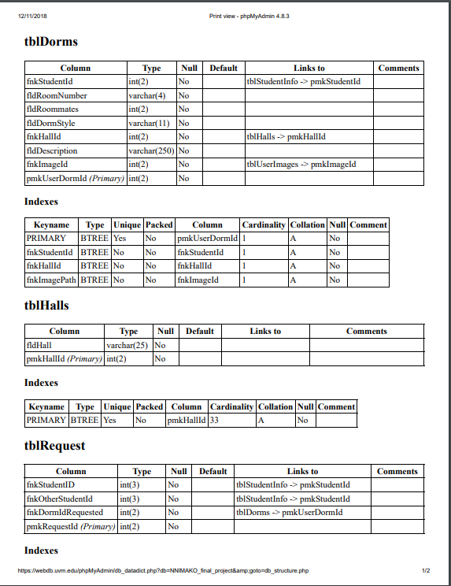

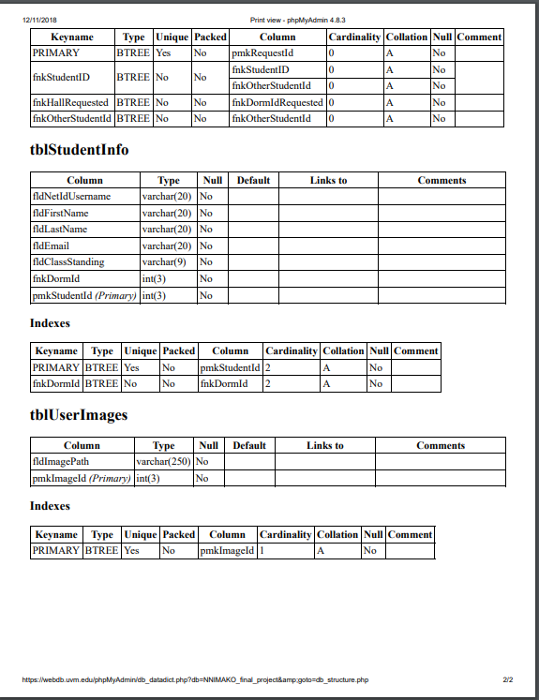

# ER- Diagram

You can use power point or any program really. Past the image here.

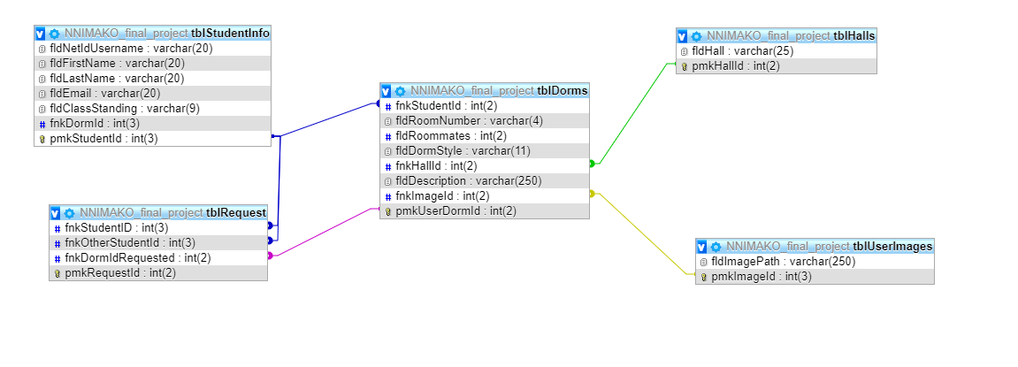

# Schema

Paste your schema here. The final version is easy to get by exporting to the screen in phpMyadmin

# Specific requirements

1. *You fill out* – This is where you would put the exact detail of what you want for the project. For example:
2. *Title for main page*: CNB Swapper
3. *Meta Description*: A web application that allows undergraduates from the university of Vermont get the opportunity to upload or list their dorm on a market for swap or change
4. *Meta Character set*: UTF - 8
5. *Logo*:



1. *Main page photo*:

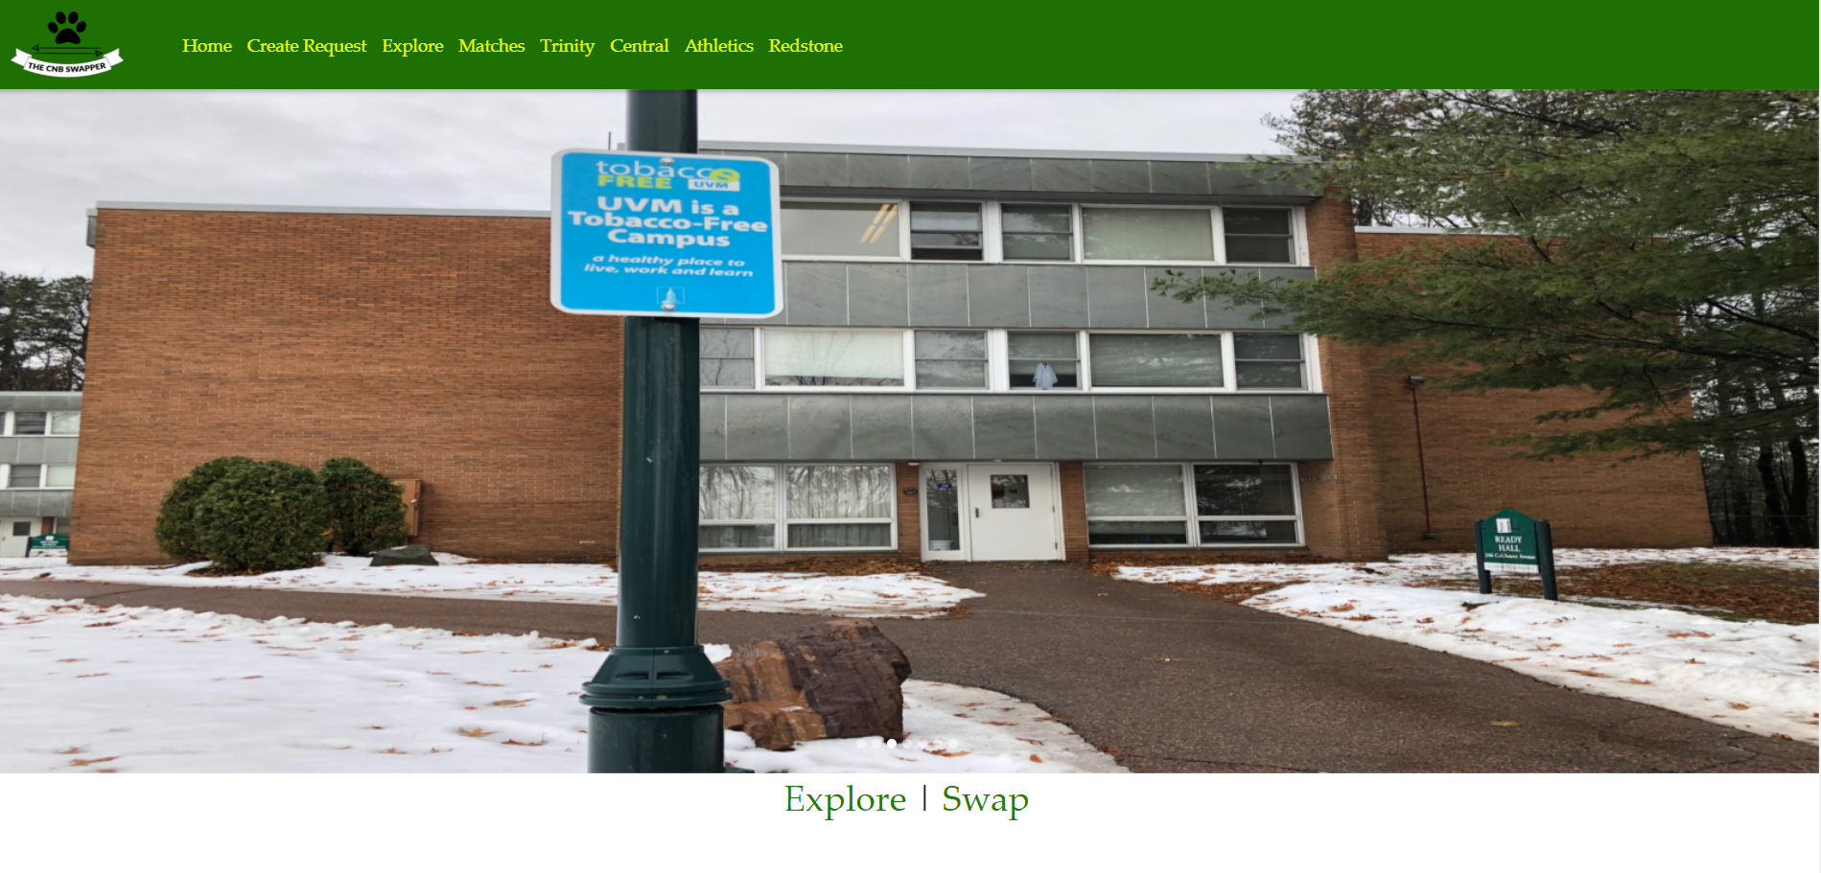

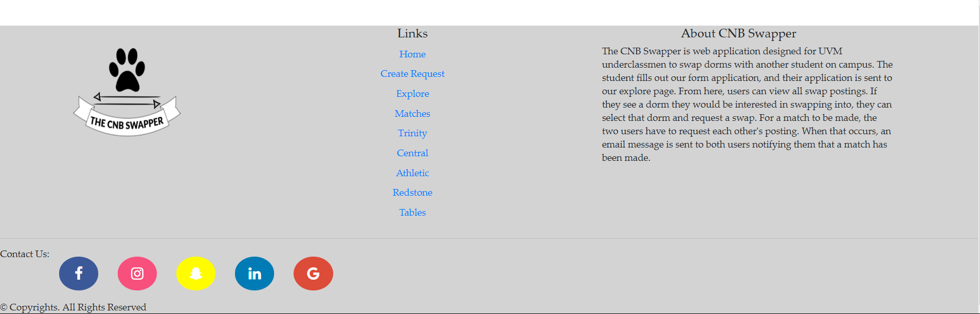

1. *Campuses pages*:

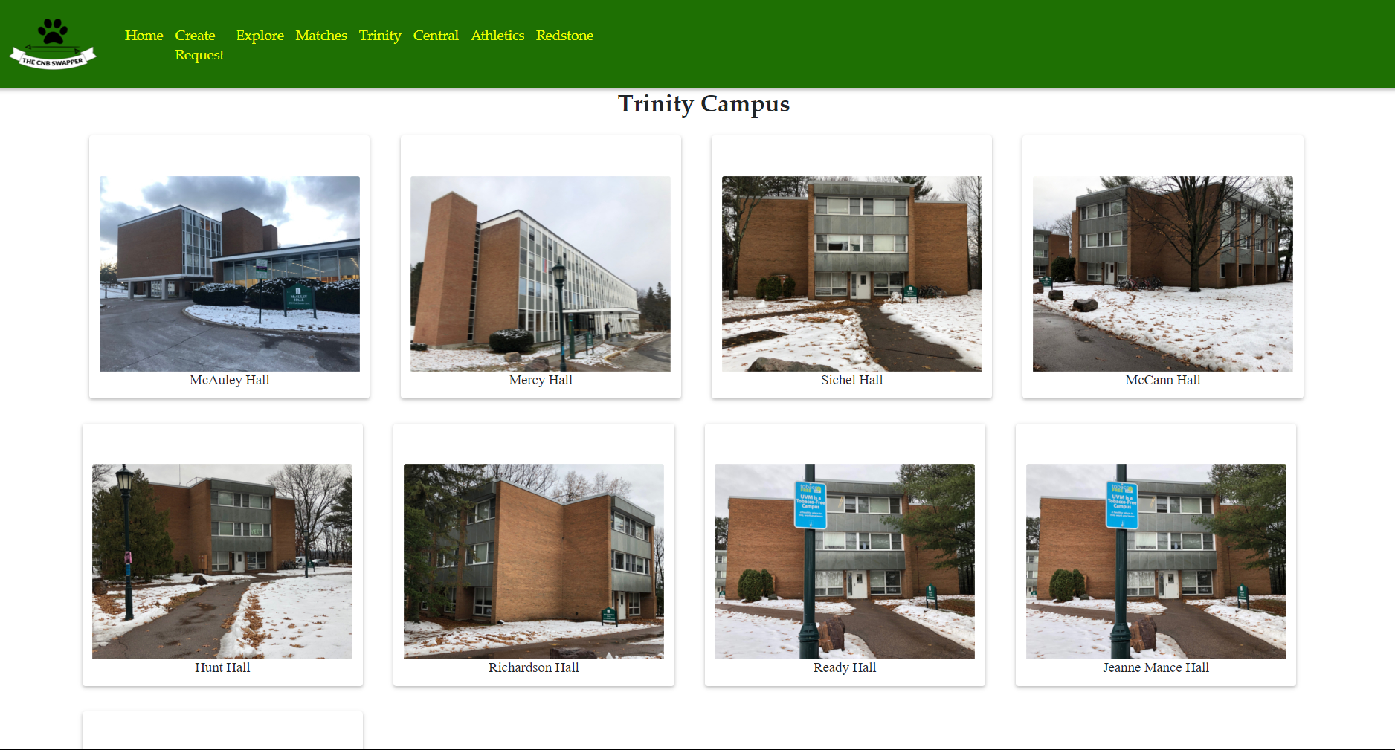This was repeated for the other campuses on campuses. I.e.: central, athletic, and Redstone

1. Create a Request Page

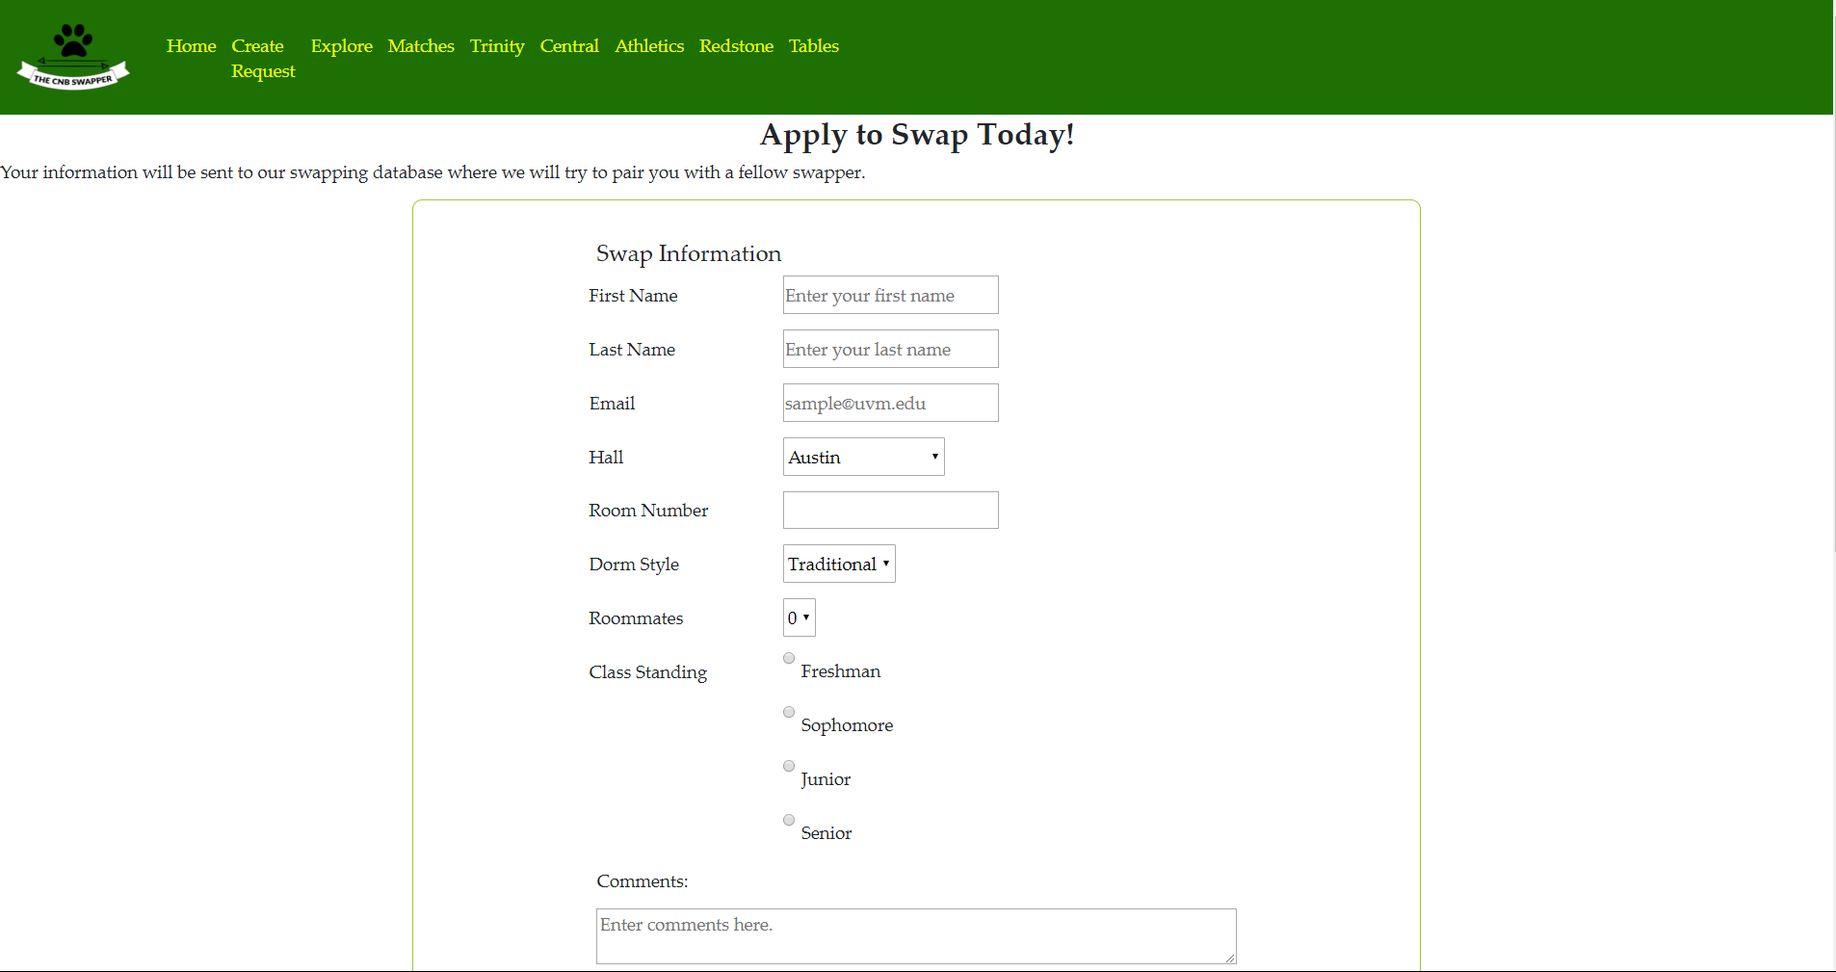

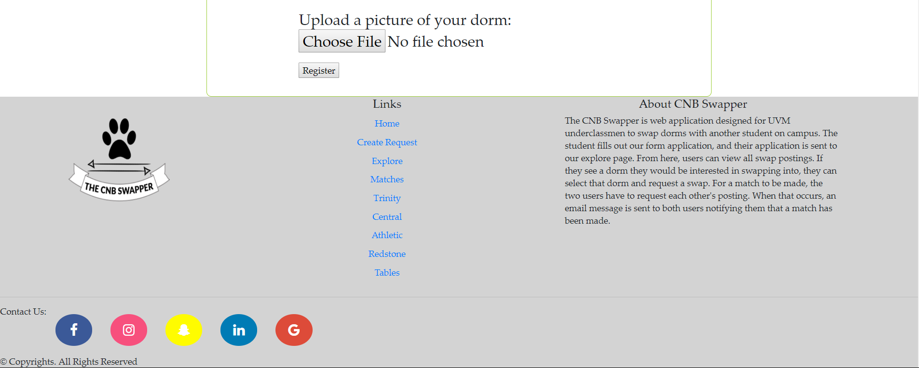

1. Explore

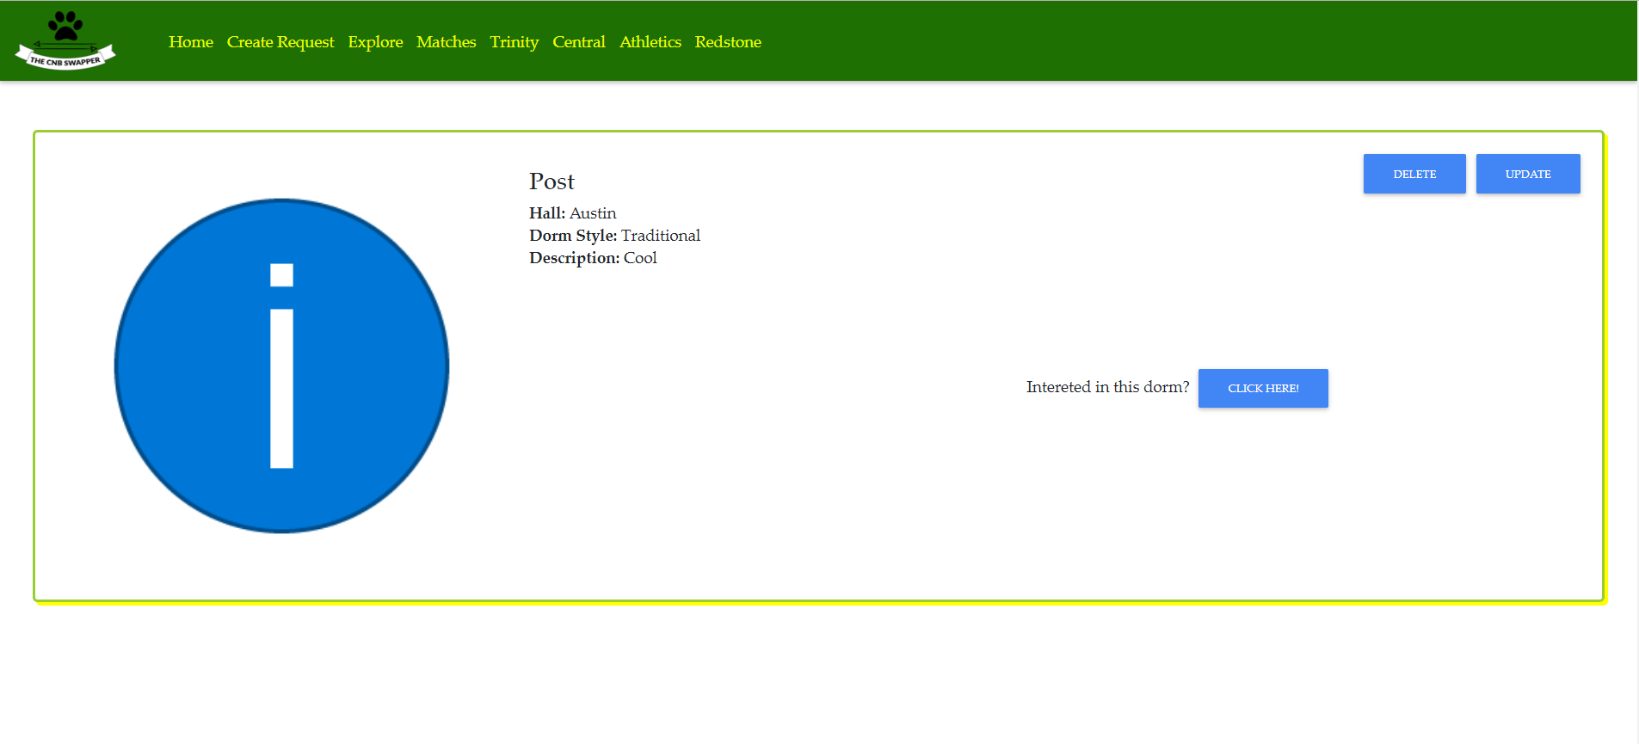

1. Matches

When There’s no matches

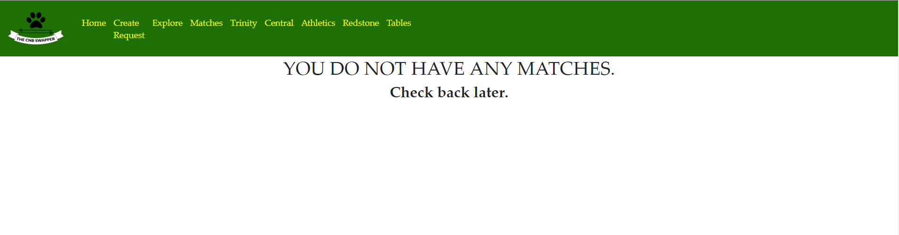

When there’s a match

